Lecture 3.1.5

Isomorphism, Homeomorphism in Graph and Sub graph
Course outcome to be covered:
CO3: Apply and recognized about the Graph Theory

Topic Objectives

The main objectives of this topic are

To understand the definitions of the following terms: Isomorphic graphs; isomorphism of graphs.

To determine whether two graphs are isomorphic; if they are, state the isomorphism.

1. Introduction

Most properties of a graph do not depend on the particular names of the vertices. For example, although graphs A and B are technically different (as their vertex sets are distinct), in some very important sense they are the “same” Figure 10: Two isomorphic graphs A and B and a non-isomorphic graph C; each have four vertices and three edges graph. For example, both graphs are connected, have four vertices and three edges. However, notice that graph C also has four vertices and three edges, and yet as a graph it seems different from the first two. Isomorphism is the idea that captures the kind of sameness that we recognize between A and B, and which distinguishes both of them from C.

2. Isomorphic Graphs

If two graphs G and H contain the same number of vertices connected in the same way, they are called isomorphic graphs (denoted by G≅ H).
It is easier to check non-isomorphism than isomorphism. If any of these following conditions occurs, then two graphs are non-isomorphic −
- The number of connected components are different
- Vertex-set cardinalities are different
- Edge-set cardinalities are different
- Degree sequences are different

2.1 Example
The following graphs are isomorphic −
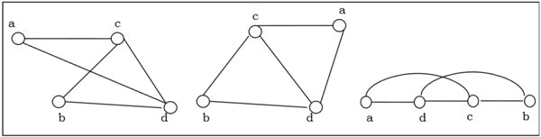

Figure1: Isomorphic Graphs in example
2.2 Definition
Consider a graph G(V, E) and G*(V*,E*) are said to be isomorphic if there exists one to one correspondence i.e. f:V→V* such that {u, v} is an edge of G if and only if {f(u), f(v)} is an edge of G*.
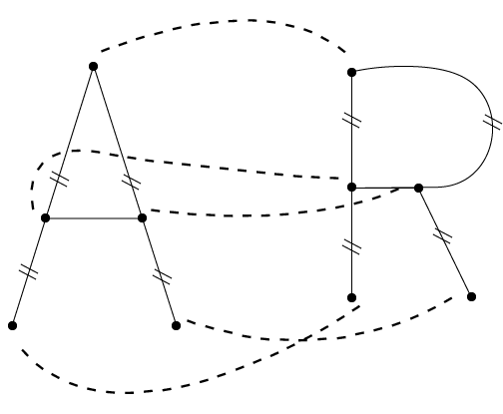

Figure2: Isomorphic Graphs

Number of vertices of graph (a) must be equal to graph (b), i.e., one to one correspondence some goes for edges.
In other words
An isomorphism between two graphs G1 and G2 is a bijection f:V1→V2 between the vertices of the graphs such that {a,b} is an edge in G1 if and only if {f(a),f(b)} is an edge in G2.
Two graphs are isomorphic if there is an isomorphism between them. In this case we write G1≅G2.
An isomorphism is simply a function which renames the vertices. It must be a bijection so every vertex gets a new name. These newly named vertices must be connected by edges precisely when they were connected by edges with their old names.

3. Homeomorphic Graphs:
A homomorphism from a graph G to a graph H is a mapping (May not be a bijective mapping)h:G→H such that − (x,y)∈E(G)→(h(x),h(y))∈E(H). It maps adjacent vertices of graph G to the adjacent vertices of the graph H.

3.1 Properties of Homeomorphisms
- A homomorphism is an isomorphism if it is a bijective mapping.
- Homomorphism always preserves edges and connectedness of a graph.
- The compositions of homeomorphisms are also homeomorphisms.
- To find out if there exists any homeomorphic graph of another graph is a NP complete problem.
3.2 Definition
Two graphs G and G* are said to homeomorphic if they can be obtained from the same graph or isomorphic graphs by this method. The graphs (a) and (b) are not isomorphic, but they are homeomorphic since they can be obtained from the graph (c) by adding appropriate vertices.
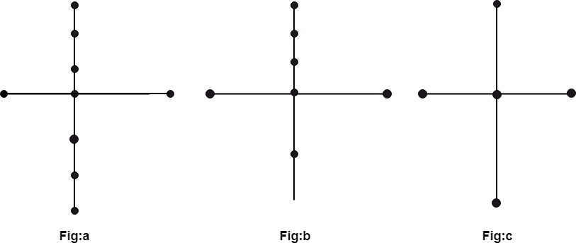

Figure3: Homeomorphic Graphs

Graphs that are basically the same (but perhaps not equal) are called isomorphic. We will give a precise definition of this term after a quick example:

4. Examples of Isomorphic and Homeomorphic graphs

Example 1.
Consider the graphs:
G1=(V1,E1) where V1={a,b,c} and E1={{a,b},{a,c},{b,c}};
G2=(V2,E2) where V2={u,v,w} and E2={{u,v},{u,w},{v,w}}. Are these graphs the same?
Solution:
The two graphs are NOT equal. It is enough to notice that V1≠V2V1≠V2 since a∈V1a∈V1 but a∉V2.a∉V2. However, both of these graphs consist of three vertices with edges connecting every pair of vertices. We can draw them as follows:

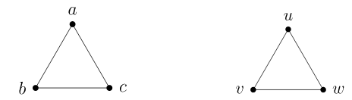

Figure4: Isomorphic Graphs in Example1

Clearly we want to say these graphs are basically the same, so while they are not equal, they will be isomorphic. We can rename the vertices of one graph and get the second graph as the result.

Example 2.
Decide whether the graphs G1=(V1,E1) and G2=(V2,E2) are equal or isomorphic.
V1={a,b,c,d}, E1={{a,b},{a,c},{a,d},{c,d}}
V2={a,b,c,d}, E2={{a,b},{a,c},{b,c},{c,d}}
Solution:
The graphs are NOT equal, since {a,d}∈E1 but {a,d}∉E2. However, since both graphs contain the same number of vertices and same number of edges, they might be isomorphic (this is not enough in most cases, but it is a good start).
We can try to build an isomorphism. How about we say f(a)=b, f(b)=c, f(c)=d and f(d)=a. This is definitely a bijection, but to make sure that the function is an isomorphism, we must make sure it respects the edge relation. In G1 , vertices a and b are connected by an edge. In G2, f(a)=b and f(b)=c are connected by an edge. So far, so good, but we must check the other three edges. The edge {a,c} in G1 corresponds to {f(a),f(c)}={b,d}, but here we have a problem. There is no edge between bb and d in G2. Thus f is NOT an isomorphism.
Not all hope is lost, however. Just because f is not an isomorphism does not mean that there is no isomorphism at all. We can try again. At this point it might be helpful to draw the graphs to see how they should match up.

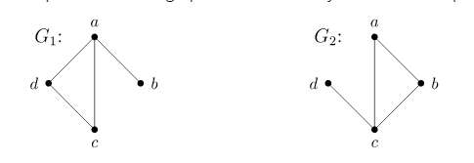

Figure5: Isomorphic Graphs in example

Alternatively, notice that in G1, the vertex aa is adjacent to every other vertex. In G2, there is also a vertex with this property: c. So build the bijection g:V1→V2 by defining g(a)=c to start with. Next, where should we send b?b? In ,G1, the vertex bb is only adjacent to vertex a.a. There is exactly one vertex like this in G2, namely d. So let g(b)=d. As for the last two, in this example, we have a free choice: let g(c)=b and g(d)=a (switching these would be fine as well).
We should check that this really is an isomorphism. It is definitely a bijection. We must make sure that the edges are respected. The four edges in G1 are
{a,b},{a,c},{a,d},{c,d}.
Under the proposed isomorphism these become
{g(a),g(b)},{g(a),g(c)},{g(a),g(d)},{g(c),g(d)}{g(a),g(b)},{g(a),g(c)},{g(a),g(d)},{g(c),g(d)}
{c,d},{c,b},{c,a},{b,a},{c,d},{c,b},{c,a},{b,a},
which are precisely the edges in G2.G2. Thus gg is an isomorphism, so G1≅G2

Sometimes we will talk about a graph with a special name (like KnKn or the Peterson graph) or perhaps draw a graph without any labels. In this case we are really referring to all graphs isomorphic to any copy of that particular graph. A collection of isomorphic graphs is often called an isomorphism class. ¹

5. Sub graph
There are other relationships between graphs that we care about, other than equality and being isomorphic. For example, compare the following pair of graphs:

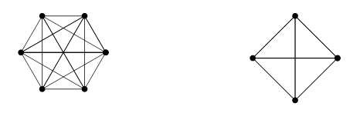

Figure6: Sub Graphs

These are definitely not isomorphic, but notice that the graph on the right looks like it might be part of the graph on the left, especially if we draw it like this:
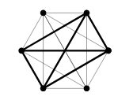

We would like to say that the smaller graph is a subgraph of the larger.
We should give a careful definition of this. In fact, there are two reasonable notions for what a sub graph should mean.

We say that G′=(V′,E′)G′=(V′,E′) is a subgraph of G=(V,E),G=(V,E), and write G′⊆G,G′⊆G, provided V′⊆VV′⊆V and E′⊆E.E′⊆E.
We say that G′=(V′,E′)G′=(V′,E′) is an induced subgraph of G=(V,E)G=(V,E) provided V′⊆VV′⊆V and every edge in EE whose vertices are still in V′V′ is also an edge in E′.

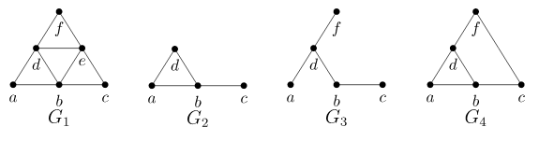

Figure7: Sub Graphs in example

Notice that every induced subgraph is also an ordinary subgraph, but not conversely. Think of a subgraph as the result of deleting some vertices and edges from the larger graph. For the subgraph to be an induced subgraph, we can still delete vertices, but now we only delete those edges that included the deleted vertices.

In other words:

A subgraph of a graph G=(V, E) is a graph G'=(V',E') in which V'⊆V and E'⊆E and each edge of G' have the same end vertices in G' as in graph G.

Note: A single vertex is a subgraph.
Example: Consider the graph G shown in fig. Show the different subgraph of this graph.
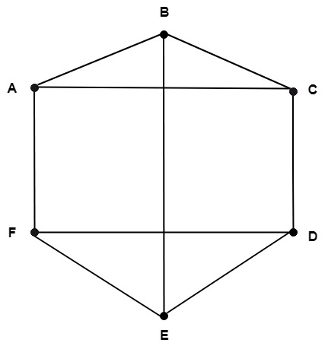

Figure8:

Solution: The following are all sub graphs of the above graph as shown in fig:
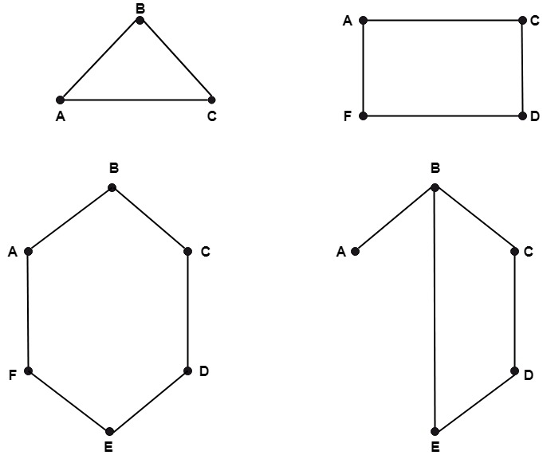

Spanning Sub graph:
A graph G₁ is called a spanning sub graph of G if G₁ contains all the vertices of G.
Example: The following fig is the spanning sub graph of the graph shown in Fig:

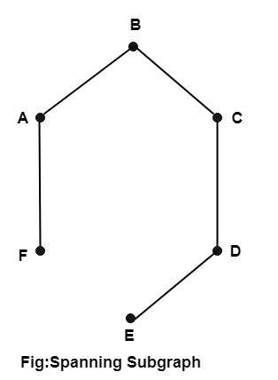

Figure9: Spanning Sub Graphs

Summary
- Introduction Isomorphism is the idea that captures the kind of sameness that we recognize between A and B
- Isomorphic Graphs If two graphs G and H contain the same number of vertices connected in the same way, they are called isomorphic graphs
- Homeomorphic Graphs Two graphs G and G* are said to homeomorphic if they can be obtained from the same graph or isomorphic graphs
- Examples of Isomorphic and Homeomorphic graphs
- Sub graph A sub graph of a graph G=(V, E) is a graph G'=(V',E') in which V'⊆V and E'⊆E and each edge of G' have the same end vertices in G' as in graph G.
- Spanning Sub graph A graph G₁ is called a spanning sub graph of G if G₁ contains all the vertices of G.
- Examples of sub graph

FAQs
- How do you prove two graphs are not isomorphic
Here's a partial list of ways you can show that two graphs are not isomorphic.
Two isomorphic graphs must have the same number of vertices.
Two isomorphic graphs must have the same number of edges.
Two isomorphic graphs must have the same number of vertices of degree n.
- How many non isomorphic simple graphs are there
There are 4 non-isomorphic graphs possible with 3 vertices.
- How many simple graphs are there on 4 vertices?
11 simple graphs
There are 11 simple graphs on 4 vertices (up to isomorphism). Any such graph has between 0 and 6 edges; this can be used to organize the hunt. (With more vertices, it might also be useful to first work out the possible degree sequences.)

Applications in Engineering
1. Cryptography One application of graph isomorphism is cryptography, utilizing something known as a zero knowledge proof.
• Zero knowledge proof - a method by which one party can prove to another party (the verifier) that a given statement is true, without conveying any information apart from the fact that the statement is indeed true.
• Pool ball example
2. Layout Versus Schematic The layout versus schematic is the class of electronic design automation verification software that determines whether a particular circuit layout corresponds to the original circuit diagram of the design
3. Biometrics
• Fingerprint scanners
• Facial recognition
• Retina scanners
4. Other misc. applications
• Linking two accounts together for the same person
• Recognizing web users based on their behavior
• Recognizing plagiarism
• Analysis of business relations
• Analysis of social structures
• Automata theory language equivalence
• Recognizing geographic locations with desired properties
5. Neuromorphic Computing
• Brain inspired computing
• Motivations
• Lower power
• Learning

References:
Video Links:
- https://www.youtube.com/watch?v=W9nJRN3ajuk
- https://www.youtube.com/watch?v=yFpRpxOry-A
- https://www.youtube.com/watch?v=lk5-dlvUhLE
Website:
- https://www.geeksforgeeks.org/mathematics-graph-isomorphisms-connectivity/
- https://mathworld.wolfram.com/IsomorphicGraphs.html
- https://www.gatevidyalay.com/graph-isomorphism/
Courses:
- https://www.coursera.org/specializations/discrete-mathematics
- https://nptel.ac.in/courses/106/106/106106094/
- https://www.udemy.com/course/discrete-math/

